Acceleration of a Mass by Gas Expansion

Calculations
The equation for the speed, v, of the mass as a function of the volume parameter, h, is:
where m is the mass, U₀ is the starting internal energy, h₀, is the starting boundary of the gas, and h is the present boundary of the gas. Now we recognize that v=dh/dt so that equation can be re-written:
Again we can re-write equation by keeping all h terms on the left side of the equation:
Now we would like to integrate both sides of this equation. To do this for the left side we first make the change of variable u=h₀/h. Then
Converting the left hand side of equation to be variable in u we have:
The integration of the right side of equation is trivial and the integral of the left side can be found in tables:
The u integral in equation has upper limit u=1 and lower limit u=h₀/h where h>h₀. At its upper limit the result is zero. Equation 6 can be solved for the time, t, as a function of u:
If we change h in uniform increments and compute the change of time at these values of h, we can obtain dh/dt which is the speed of the mass. To start let's re-write equation in terms of h:
where I have defined v_{max} as the square root of 2U₀/m which is the maximum speed that can be achieved. Then speed is defined as:

Figure
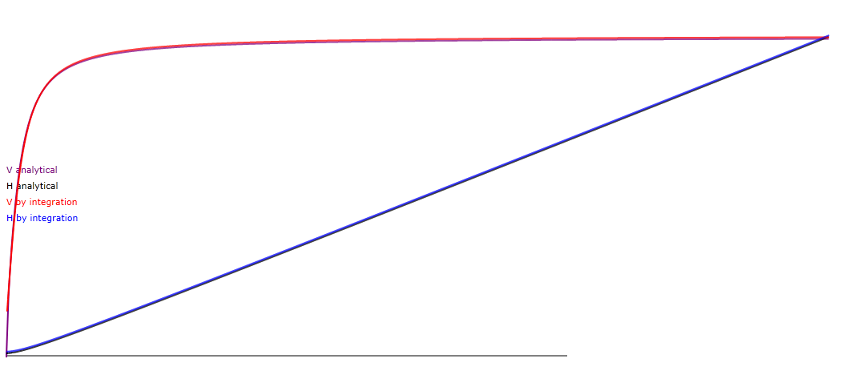
time
Plot of the mass speed V (red and purple) and position H (black and blue) versus time. The results are by numerical integration and calculus integration, respectively.

