Aircraft Moments and Rotation

Introduction
An aircraft is an example of a somewhat symmetrical object that has three principal axes of rotation, pitch, roll, and yaw. Since the wings and fuselage masses usually lie in almost the same plane, it can be modeled with reasonable accuracy as a planar object. The advantage of doing this is that the yaw moment becomes a simple sum of the pitch and roll moments and all three axes of rotation pass through the center of mass (CM) which usually lies at about 30% of the wing chord behind the wing leading edge. A simplified diagram of the masses and CM location is shown below.

Figures
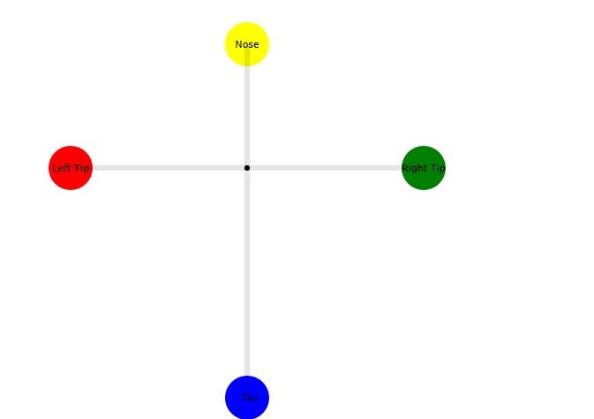
Figure 1: Showing the aircraft modeled as 4 spherical masses. The wingtips, nose, and tail are labeled. The black dot is the center of mass, so the tail sphere has to have less mass than the nose sphere.

Moments of Inertia
These will be labeled I_{P}, I_{R}, and I_{Y} where the subscripts stand for pitch, yaw, and roll, respectively. To define them we first need to compute the nose and tail masses from the center of mass location. If the CM is located at a fraction C_{g} from the nose, then the ratio of the nose to tail mass is:
If the sum of the nose and tail masses (fuselage mass) is M_{f} then the nose and tail masses are:
Since all the nose and tail weights are concentrated in two small spheres, the pitch moment of inertia about the CM is:
where the fuselage length is l_{f}. The above equation makes sense since for C_{g}=1/2, and l_{f} =2l, then we would have I=M_{f}l² as expected for small masses located at distance l from the CM.
The roll moment of inertia is:
where M_{w} is the total mass of the wings and l_{w} is the wingspan.
Since we have a planar object, the yaw moment of inertia is just the sum of the pitch and roll moments:

