Graphics Description

Figures
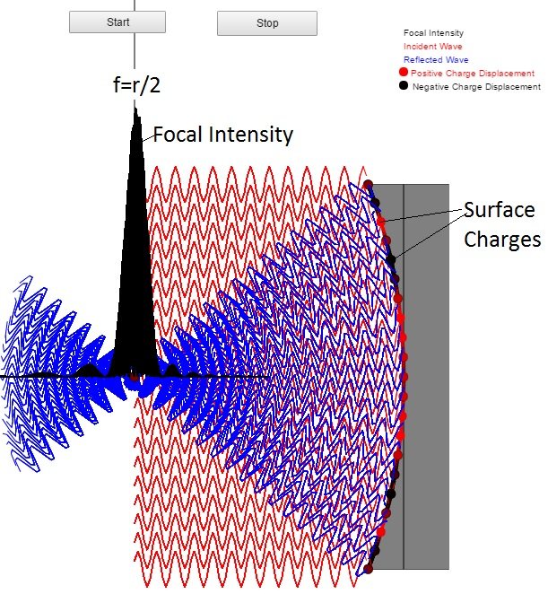
Figure 1: Wave picture of concave mirror reflection. As shown the incident waves (red) are parallel to the axis of the mirror. The reflected waves converge symmetrically to the axis of the mirror. The surface charge displacements are shown as red (indicating positive displacement) and black (indicating negative displacement). The surface charge oscillation is responsible for the emission of the reflected waves which could be in any direction around the hemisphere defined by the mirror surface normal. Only the emissions that converge on the mirror axis are shown since these are the only possible ones that could add up coherently. Not even all of these add up coherently. It is the waves that converge on the axis at distance r/2 of the mirror surface whose phases are coherent at the axis.

