Graphics Description for Convex Lens

Figures
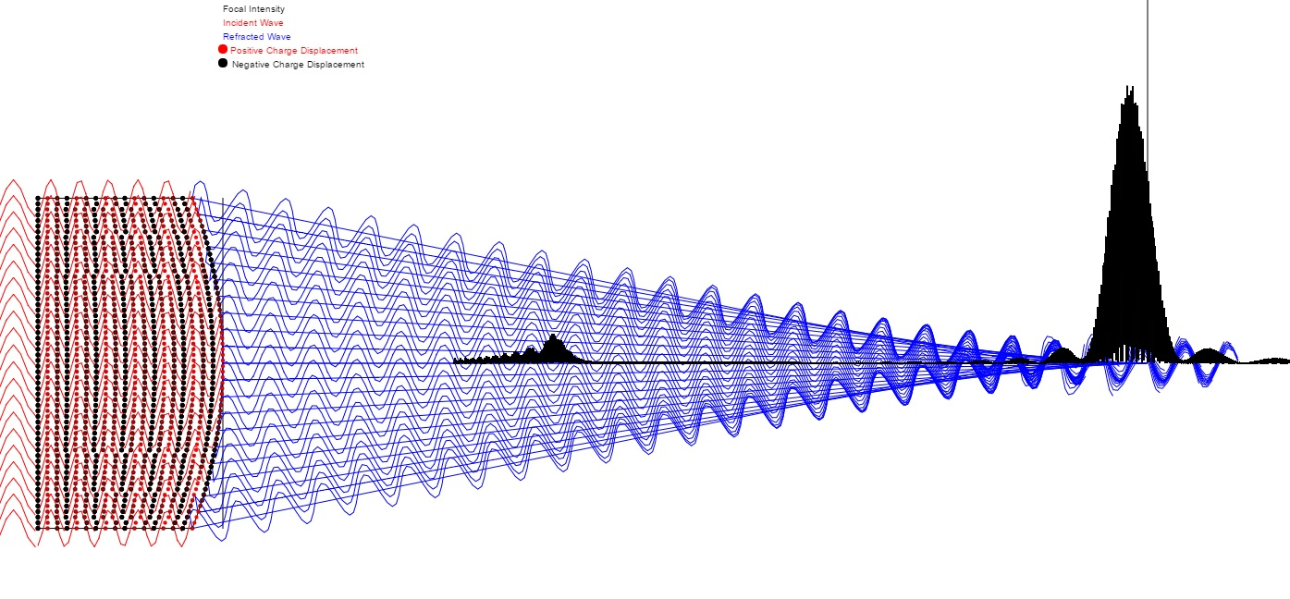

Figure 1: Wave picture of convex lens focus. As shown the incident waves (red) are parallel to the axis of the mirror. The refracted waves converge symmetrically to the axis of the lens. The lens dipole charge displacements are shown as red (indicating positive displacement) and black (indicating negative displacement). The charge oscillation is responsible for the transmission of the refracted waves which could be in any direction around the hemisphere defined by the curved lens surface normal. Only the emissions that converge on the lens axis are shown since these are the only possible ones that could add up coherently. Not even all of these add up coherently. It is the waves that converge on the axis at distance R/(n-1) of the mirror surface whose phases are reasonably coherent at the axis as shown by the black focal intensity plot. The black vertical line is drawn at distance r/(n-1) from the apex of the lens. In general, the best focus will be shorter than this because of finite lens diameter.

