The Best Trajectory to Negotiate a Turn in the Road

Introduction
This animation will show the resulting lateral accelerations for two types of curve. First is the ideal curve that is the largest one that can stay within the bounds of the lane. Second is a curve that is adjustable by the user. For both types of curve, the speed profile is adjustable via a smooth Bezier curve.

Figures
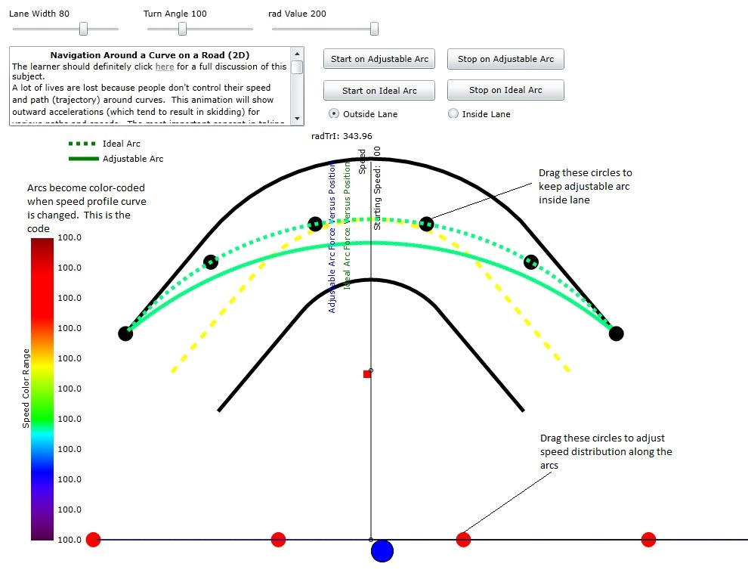
Figure 1: Diagram of the animation describing how to use the adjustable arc and speed profile.

Computing the ideal arc
dr
a
trajectory starting
point
road outer
boundary
trajectory
lane width
s
Figure 1: Diagram of the turn outer boundary and the possible trajectory. Symbol a is half of the total turn angle while symbol s is the straight line distance from the start of the curved trajectory to the start of the arc that represents the outer boundary of the road. as can be seen, the parameter dr is the difference between the trajectory radius and the road outer bound radius.
It is obvious from the figure that the value of dr is:
Also the lane width, w, is
From equation we may compute s in terms of w and a:
and from equations 1.5 and 1.7 we can compute dr:

Computing the Lateral Acceleration
I assume we have a parametric path in 2D space:

where i is the counter integer for successive points, what is the transverse acceleration needed to stay on the path?
The transverse acceleration depends on the rate of change of the vector normal to the path. If we just have a listing of then we can make an estimate of the change of the unit normal, n, by taking the following quantities:
First the local normal is computed from:
where x₀ and y₀ are immediately previous values of x,y and x and y are the present values. In order to compute the change in normal vector we need to have saved an immediately previous value of n as n₀
Then
is the local change. The acceleration a normal to the path then is

where ds is the spacing along the path of the points and dt is the time increment between points. Please take note that it is not assumed that the curve is part of a circle.

