Gas Damping Via Adiabatic Compression

Introduction
A mechanical damper is usually composed of a cylinder and piston filled on both sides with a nearly incompressible fluid. Since the fluid is nearly incompressible, we place a hole in the piston to allow the fluid to pass through. The amount of movement restriction that this arrangement provides depends on the size of the hole and the viscosity of the fluid. In this animation, we will have the same piston and cylinder arrangement but we will use a mono-atomic gas that is highly compressible. For illustration simplicity, the hole will consist of a gap between the piston and cylinder. In order to show significant results, we will permit piston speeds that are approximately equal to the average thermal speeds of the atoms. This will show how interesting atomic density distributions can build up on the face of the advancing piston.

Figures

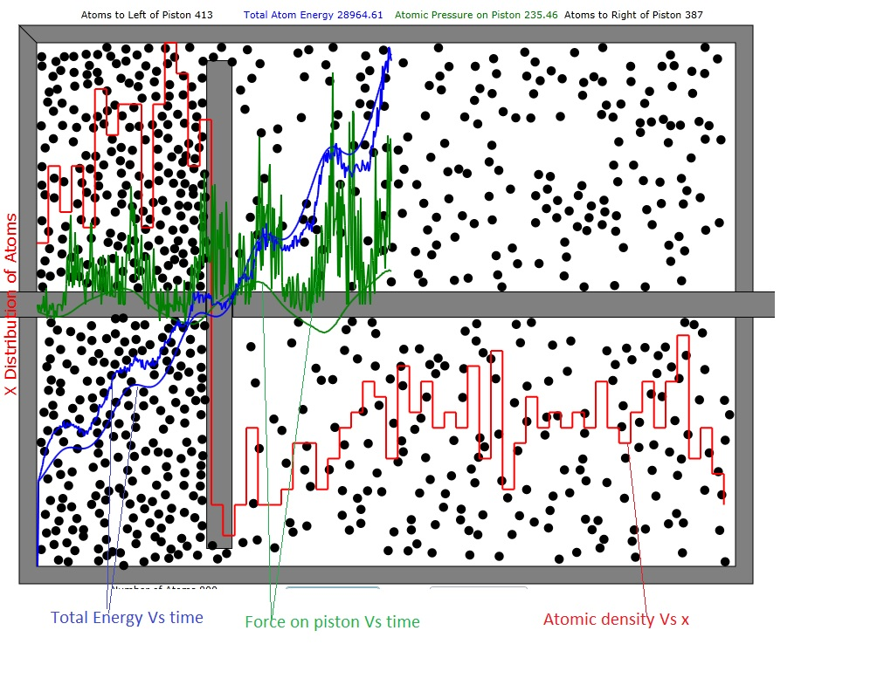
Figure 1: Cylinder and Piston filled with 800 atoms. In this case 387 are to the right of the piston and 413 to left. The total atom energy has increased from about 3500 to 28965 units. By viewing the red histogram, one can see that the density of the atoms to the right of the right-going piston is highest. This is because piston speed slightly exceeds average atomic speed so the atoms can't diffuse away fast enough. The smooth blue curve is the first-principles result for the total atom energy and the smooth green curve is the first principles result for the force on the piston.

Calculation of Energy during adiabatic compression
Adiabatic compression means that no heat flows into the system under observation during that compression. Atoms do gain kinetic energy (the temperature increases) during adiabatic compression because of the mechanical energy provided by the moving piston. The reason is that a atom with x velocity component -v_{x} (where v_{x}>0 for the time being) that collides with the front side of a piston moving in the x direction at speed v_{p}>0 rebounds with an x component of speed v_{x}+v_{p} i.e.

$$v_{x}^{'}=−(−v_{x})+v_{p }=v_{x}+v_{p}$$
and therefore the colliding atom gains energy.
We will use the term "front side" to describe the face of the piston whose outward normal is parallel with v_{P} and the term "back side" to describe the face of the piston whose outward normal is anti-parallel with v_{P.}
One might object that the opposite speed change happens when an atom hits the back side of the piston and that is absolutely correct. However, as the animation shows, there is often a much higher density atoms on the front side of the piston than the back side and therefore there is a net energy gain per cycle.
In the following, we will consider only the motion of the piston in the positive x direction. By symmetry, the results for energy transfer for motion in the negative x direction must be the same. Also we set the piston coordinate, x_{P}, to zero when the piston is at the center of the cylinder.
The average time between collisions of the atom with the front of the moving piston is
$τ_{F}=\frac{2(L/2−x_{p})}{v_{x}>}$
and the time between collisions with the back of the moving piston is

$$τ_{B}=\frac{2(L/2+x_{p})}{v_{x}>}$$
where L is the total length of the cylinder and <v_{x}> is the average x component of the velocity.
$$v_{x}\text{>=}\sqrt{\frac{E_{\text{total}}}{\text{mN}}}$$
where E_{total} is the total kinetic energy of the atoms and N is the total number of atoms.

The total rate of collision on the front and back side is then just the number of atoms, N, on that side divided by its average interval between collisions:
$$\frac{{\text{dN}}_{F}}{\text{dt}}=N_{F}<v_{x}>\frac{}{2\left(L/2−x_{p}\right)}$$
$$\frac{{\text{dN}}_{B}}{\text{dt}}=N_{B}<v_{x}>\frac{}{2\left(L/2+x_{p}\right)}$$
The energy transfer per collision is just due to the added or reduced x component of velocity due to the moving piston:
$$δE=\frac{1}{2}\left(m(v_{x}+v_{P})^{2}\right)−\frac{1}{2}{\text{mv}}_{x}^{2}=\frac{1}{2}m\left(2v_{x}v_{p}+v_{p}^{2}\right)$$
where m is the mass of the atom and v_{p} can be positive or negative.
Then the rate of energy added per second to atoms colliding with the front of the piston is :
$$\frac{{\text{dE}}_{F}}{\text{dt}}=\frac{{\text{dN}}_{F}}{\text{dt}}δE=\frac{1}{4}N_{F}<v_{x}>\frac{}{\left(L/2−x_{p}\right)}m\left(2v_{x}v_{p}+v_{p}^{2}\right)$$
and the rate of energy subtracted per second from atoms colliding with the back of the piston is:
$$\frac{{\text{dE}}_{B}}{\text{dt}}=\frac{{\text{dN}}_{B}}{\text{dt}}δE=\frac{1}{4}N_{B}<v_{x}>\frac{}{\left(L/2+x_{p}\right)}m\left(−2v_{x}v_{p}+v_{p}^{2}\right)$$
So the program continuously integrates the dE/dt increments to estimate the added kinetic energy associated with the periodic adiabatic compressions. Of course here, x_{p} and v_{p} vary sinusoidally with time.

Calculation of Force on Piston
The net force on the moving piston due to atoms hitting it is calculated in an entirely similar way to the energy induced in the atomic gas by the piston. First we have the rates of atoms hitting the front and back of the piston:
$$\frac{1}{τ_{F}}=v_{x}>\frac{}{2(L/2−x_{p})}$$
$$\frac{1}{τ_{B}}=v_{x}>\frac{}{2(L/2+x_{p})}$$
The momentum imparted to the moving piston for each collision averages:
$${δp}_{F}=−m(2<v_{x}\text{>+}v_{P})$$
$${δp}_{B}=m(2<v_{x}>−v_{P})$$
And therefore the total momentum in the positive x direction imparted per second from all the atoms hitting the front and back of the piston is:
$$\frac{{δP}_{F}}{\text{dt}}=−\frac{N_{F}}{τ_{f}}m(2<v_{x}\text{>+}v_{P})=−N_{F}m(2<v_{x}\text{>+}v_{P})v_{x}>\frac{}{2(L/2−x_{p})}$$
$$\frac{{δP}_{B}}{\text{dt}}=−\frac{N_{B}}{τ_{f}}m(2<v_{x}>−v_{P})=N_{B}m(2<v_{x}>−v_{P})v_{x}>\frac{}{2(L/2+x_{p})}$$
and therefore the total force on the piston is:
$$F=−N_{F}m(2<v_{x}\text{>+}v_{P})v_{x}>\frac{}{2(L/2−x_{p})}+N_{B}m(2<v_{x}>−v_{P})v_{x}>\frac{}{2(L/2+x_{p})}$$
Obviously, if N_{F}=N_{B} we have a force on the piston even when v_{p}=0. That is reasonable, since, when, for example, x_{P}>0, the gas on the right side is compressed.

