Gas Expansion into a Vacuum Environment

Introduction
This animation considers the energy and pressure of a gas that is expanding due to the motion of one of the walls of its container. For this case I will assume that the wall is moving uniformly so as to increase the volume accessible to the gas and that the wall does not experience any retarding force because of any external gas pressure. This is in some ways more complicated than the usual gas physics situations where, for example, the gas expands while the pressure remain constant.

Figures
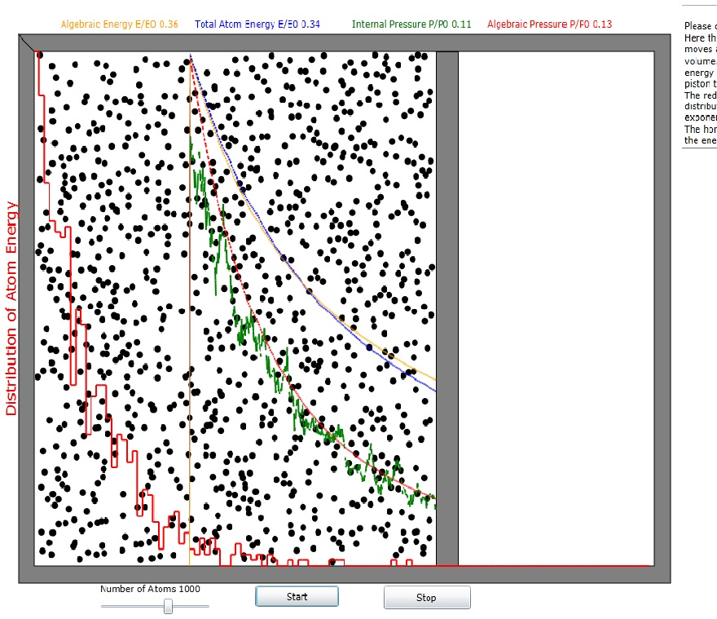
Figure 1: Gas expansion apparatus diagram. The moving wall (piston) starts at the location of the vertical orange line and moves to the right end of the chamber. Energy and pressure are plotted in blue and green, respectively.

Physics and Math
Since the wall moves away from the occupied volume, the gas atoms lose momentum and kinetic energy when hitting it. As a result of the energy reduction they impact all of the walls with less momentum and the pressure is reduced.

In the reference frame of the piston, the momentum change can be written:

where the prime on p_{p} indicates the value of momentum after the collision.
In the laboratory reference frame:
which results in the following energy change:
Obviously v_{x}>v_{p} if the atom is to hit the piston. When v_{x}=v_{p} + δv_{x} then becomes
regardless of the magnitude of δv_{x}.
For an atomic area of x_{p}*h, where h is the piston height, the number of piston hits per second expected is
where x_{p} is the length of the cylinder and h is the height of the piston.
Thus, combining equations and , the expected energy loss per second is
When v_{x} is about equal to v_{p} then v_{x} doesn't change much nor does energy. Now we must consider another question: how to compute a meaningful value for <v_{x}> where only
<v_{x}> is greater than v_{p} is meaningful. That involves integrals over the Maxwell distributions:

Converting equation to average energy terms <E>=m<v_{x}²> we have:
Now v_{p}dt=δx_{p} so we have the following differential equation which can only be solved iteratively:
It turns out the that exponential value for the piston speeds used in the program is very close to 1.0 so the program uses the value

Appendix: Rate of wall hits
Assuming that the container dimensions are much greater that the mean free path, l, we have the following cases:
1. If the distance of the atom from the wall is equal to l, then the probability that the atom hits the wall in l/v_{x} seconds is 0.5.
2. If the distance of the atom from the wall is equal to fl, then the probability that the atom hits the wall in l/v_{x} seconds is 0.5/f².
There are N(fl/x_{P}) atoms within nl of the piston.
Converting statement 2 into an equation we have:
The number of atoms at distance |x_{p}-x| hitting the wall per second is then n(x)v_{x}|x-x_{p}|/v_{x}.
The mean free path is
where a is the radius of the hard disc atom.
Then equation becomes:
Now we must integrate this expression over all the x's from 0 to x_{p}.

