Forced Harmonic Oscillator Motion

Introduction
The forced simple harmonic oscillator’s (FSHO) motion is a good approximation of the driven motion of practically all real-world objects that present periodic motion. Even though the SHO’s restoring force is linear in displacement, its motion is a good approximation for a motion of a system with non-linear restoring force, at least within a limited range of the latter’s displacement. Therefore a good grasp on the dynamics of the FSHO goes a long way toward understanding the dynamics of the real world.

Calculations:

The picture on the left shows the important parameters of the SHO. They include a spring (shown here as a coil with spring constant k Newtons per meter), a drag element (shown here as a shock absorber, often called a dashpot, with a constant b Newtons-seconds per meter) and a Mass, M, at the bottom. The function of the spring is to restore the mass to an equilibrium height and the function of the drag element is to realistically simulate the decay of any oscillation that is in progress.
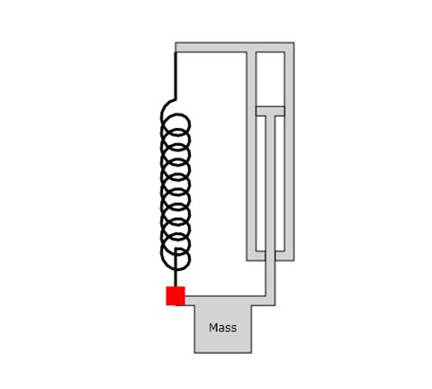
Spring
Constant=k
Drag element
Constant=b

The equation that describes the motion of the mass is:
(1)
where F₀ is the peak force and ω is the radian frequency of that force.
To solve equation 1 we make the substitution:
(2)
where i is the square root of -1, Real[] denotes the real part of the resulting value, Y is the complex peak displacement for the given force, t is time, and ω_{c} (which has units of 1/time and is complex) is a parameter for which we will solve.
Using equation 2 in equation 1 we have very easily:
(3)
The result for Y is:
(4)
For convenience we make the following definitions:
(5)

so that equation 4 becomes.
(4a)
Also, we now separate the real and imaginary parts of equation 4a by re-naming these quantities:
(6)
First, notice that the real part of Y_{Re} is positive when ω<ω₀ and negative when ω>ω₀. Also note that Y_{Im} is always negative.
Using equations 6 in equation 2 we have
(7)
We may use trigonometric identities to show the phase lag of equation 7:
(8)
Note that the phase in equation 8 is negative (a phase lag) when ω<ω₀ and positive when ω>ω₀.

Summary
Equations 6, 7, and 8 are probably the most important equations in the real world for understanding driven periodic motion. The animation accompanying this document will help you to fully appreciate these equations.

