Harmonic Oscillator Motion

Introduction
The simple harmonic oscillator’s (SHO) motion is a good approximation of the motion of practically all real-world objects that present periodic motion. Even though the SHO’s restoring force is linear in displacement, its motion is a good approximation for a motion of a system with non-linear restoring force, at least within a limited range of the latter’s displacement. Even the motion of higher energy state electrons in atoms simulates that of a harmonic oscillator. Therefore a good grasp on the dynamics of the SHO goes a long way toward understanding the dynamics of the real world.

Calculations:

The picture on the left shows the important parameters of the SHO. They include a spring (shown here as a coil with spring constant k Newtons per meter), a drag element (shown here as a shock absorber, often called a dashpot, with a constant b Newtons-seconds per meter) and a Mass, M, at the bottom. The function of the spring is to restore the mass to an equilibrium height and the function of the drag element is to realistically simulate the decay of any oscillation that is in progress.
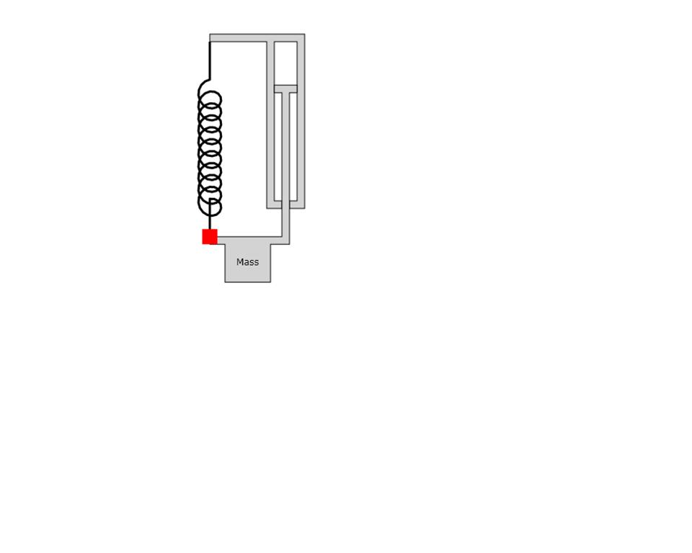
Spring
Constant=k
Drag element
Constant=b

The equation that describes the motion of the mass is:
(1)
To solve equation 1 we make the substitution:
(2)
where i is the square root of -1, Real[] denotes the real part of the resulting value, Y is the peak displacement under any preset conditions, t is time, and ω_{c} (which has units of 1/time and is complex) is a parameter for which we will solve.
Using equation 2 in equation 1 we have very easily:
(3)
The result for ω_{c} is:
(4)
We see from equation 4, that if b=0 i.e. no drag, then
(5)
where we have defined ω₀. Also, to simplify notation, we now separate the real and imaginary parts of equation 4 by re-naming these quantities:
(6)
Using equations 6 in equation 2 we have
(7)

Summary
The meaning of equation 7 is that, if we initially displace the mass from its equilibrium position by distance Y and have initial speed zero, then the subsequent motion will follow the product of the cosine periodic motion times the exponential decay coefficient.

