Lens Ray Calculation

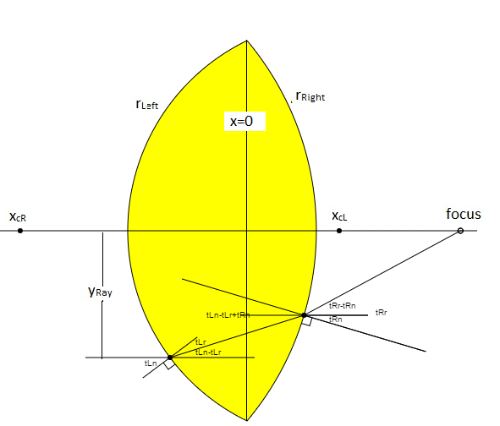
Figure 1: Ray trace showing the incident ray, the refracted rays at both surfaces, as well as the normals to the surfaces where the rays are refracted. The angles that are needed for the refraction calculations are labeled as described below.
In the labels, the first letter t means that it is referring to an angle as in the greek letter theta.

The second letter, L or R, refers to the Left or Right surface.

The third letter can be either r or n. r refers to a refracted angle with respect to the surface normal and n refers to the angle of the surface normal with respect to the x axis. This labeling is needed in order to easily see what are the incident angles and the refracted angles and the final ray angle with respect to the x axis.

Calculations
A double convex lens that is centered on the x axis is defined by the left and right radii of curvature, r_{L} and r_{R}. For convenience we will define the signs of these curvatures so that the x_{L}(y)<0 and x_{R}(y) >0. If the radius of the lens is r_{Lens} then the centers of these curves are at:
The x location of any point y<r_{Lens} on the lens is:
Note that when y=r_{Lens}, x=0 as expected for these definitions. Also note that when y<>0, x_{L} is less than zero while x_{R} is greater than zero.
If an incident ray that is parallel to the x axis hits the left surface is at then its corresponding x coordinate is at
Also the angle between the surface normal at y_{Li} and the ray is
Let the index of refraction of the lens be n.
Snell's refraction law is:
where is the angle between the surface normal and the refracted ray.
Then, using equations and , the angle between the normal and the refracted ray is
The angle of the refracted ray with respect to the x axis is
which is a negative angle when y>0 and positive when y<0 so that the refracted ray slopes toward the x axis.
The slope of he refracted ray is then
The y coordinate of the refracted ray in the lens can be written as:
In order to compute the intercept of y_{r} with the right hand surface of the lens we can re-write equation using equation and obtain
where y_{Rr} is the y intercept of y_{r}(x) with the right surface of the lens and it to be solved for.
We can greatly simplify solving equation by separating out the constants by letting
and then equation becomes:
We may conveniently square both side of equation and solve for y_{Rr} and obtain:
Having obtained the y intercept using the + sign before the radical, we can use equation to obtain the x intercept:
Finally we may use Snell's law for the refraction of the ray as it exits the right hand surface. The refracted ray's incidence angle with respect to that normal is:
Since
we have the refracted angle:
With respect to the x axis this angle is:
Finally the slope of the this ray is:
The y coordinate of the exiting ray can be expressed by:
Solving equation for x at y_{exit}=0, the ray will intercept the x axis at location:

