Statics of Two Masses Fastened to a Rigid Rod Under the Force of Gravity

Introduction
It is easy to find simple horizontal statics tutorials on the internet but I have not been able to find any that involve a tilted supports with either two masses or non-uniform mass distribution. This animation should fill that niche.

Figure
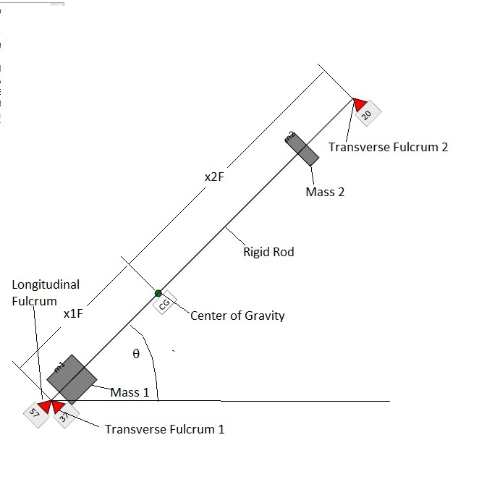
Figure 1: Showing the 3 fulcrums (scales) in red, the rigid rod on which the masses are fastened, the masses, and the center of gravity (CG) and distances from the fulcrums to the CG. Currently the longitudinal force is 57 when the transverse forces are 37 and 20, respectively.

Calculations for Lumped Masses:
Let subscript t stand for transverse to the rigid rod and subscript l stand for longitudinal to the rigid rod. Since the rod is rigid, we may treat the problem as if there were only one mass M=(m1+m2), centered at the CG where x_{CG} is
$$x_{\text{CG}}=\frac{x_{m1}m_{1}+x_{m2}m2}{m_{1}+m_{2}}$$
$$\begin{aligned}F_{l}=\text{Mg}\text{sin}(θ) \text{Longitudinal} \text{Force} \\ F_{1}x1F=F_{2}x2F \text{Torque} \text{about} \text{CG} \text{is} \text{zero} \\ (F_{1}+F_{2})\text{cos}(θ)+\text{Mg}{\text{sin}}^{2}(θ)=\text{Mg} \text{Total} \text{upward} \text{force} \text{is} \text{Mg} \\ F_{1}\left(1+\frac{x1F}{x2F}\right)\text{cos}(θ)=\text{Mg}{\text{cos}}^{2}(θ) \text{Use} \text{trig} \text{identity} \text{for} 1−{\text{sin}}^{2}θ \\ F_{1}=\frac{\text{Mg}\text{cos}(θ)}{1+x1F/x2F}; F_{\text{tRight}}=\frac{x1F}{x2F}\frac{\text{Mg}\text{cos}(θ)}{1+x1F/x2F}; \text{Solve} \text{above} \text{equation} \\ ∴ F_{1}+F_{2}=\text{Mg}\text{cos}(θ)\end{aligned}$$
Note that the resultant of all 3 forces is Mg and points upward. Also note that the upward components of F_{t} are proportional to cos²(θ), which for small θ is extremely close to 1.

Calculations for Linearly Distributed Mass
For now, assume θ=0 and let:
$$ρ(x)=ρ_{0}+ρ'x$$
$$\begin{aligned}x_{\text{CM}}=\frac{\int_{0}^{L}{xρ(x)\text{dx}}}{\int_{0}^{L}{ρ(x)\text{dx}}}=\frac{ρ_{0}{L^{2}}/2+ρ'{L^{3}}/3}{ρ_{0}L+ρ'{L^{2}}/2}=\frac{L/2[1+2ρ'L/(3ρ_{0})]}{1+ρ'L/(2ρ_{0})}≈L/2[1+2ρ'L/(3ρ_{0})][1−ρ'L/(2ρ_{0})]≈L/2[1+ρ'L/(6ρ_{0})]\end{aligned}$$
where the approximations apply for small values of ρ'L/ρ₀.
It's as if we had masses at x=0 and x=L of values:
$$\begin{aligned}m(0)=(M/2)(1−f) \\ m(L)=(M/2)(1+f)\end{aligned}$$
where
$$f=\frac{[1+2ρ'L/(3ρ_{0})]}{1+ρ'L/(2ρ_{0})}−1=\frac{ρ'L/(6ρ_{0})}{1+ρ'L/(2ρ_{0})}≈ρ'L/(6ρ_{0})$$
and where the total mass is:
$$M=\int_{0}^{L}{ρ(x)\text{dx}}=ρ_{0}L(1+ρ' L/(2ρ_{0})$$
We can also model the system as having a single mass M at the CG and then use two fulcrums to balance the torques about the CG.
Now, letting θ be variable, we must balance the torques about the CG in order to avoid rotation. If r₁ points from the CG to fulcrum 1 and r₂ points from the CG to fulcrum 2 then the total torque about the CG is zero when we have for the forces at transverse fulcrums 1 and 2:
$$F_{1}\hat{y}×r_{1}=F_{2}\hat{y}×r_{2}$$
where the carat above y indicates a unit vector. Note that
$$\hat{y}×r=|r|\text{cos}θ$$
Resolving r₁ and r₂ into x and y components we have:
$$\begin{aligned}r_{1}=x_{1}\hat{x}+y_{1}\hat{y} \\ r_{2}=x_{2}\hat{x}+y_{2}\hat{y}\end{aligned}$$
where the x's and y's with the 1 subscript have signs opposite to those with the 2 subscript. The values of x,y are:
$$\begin{aligned}x_{1}=−r_{1}\text{cos}(θ),y_{1}=−r_{1}\text{sin}(θ) \\ x_{2}=r_{2}\text{cos}(θ),y_{2}=r_{2}\text{sin}(θ)\end{aligned}$$
Then the torque balance equation becomes:

$$F_{1}r_{1}\text{cos}(θ)=F_{2}r_{2}\text{cos}(θ)$$
Of course, when the centerline of the mass distribution is tilted at angle q, we must have a longitudinal restraining force
$$F_{L}=\text{Mg}\text{sin}θ$$
Just as before we have:
$$F_{1}=\frac{\text{Mg}\text{cos}(θ)}{1+{r_{1}}/{r_{2}}}; F_{2}=\frac{r_{1}}{r_{2}}\frac{\text{Mg}\text{cos}(θ)}{1+{r_{1}}/{r_{2}}};$$
Note that the sum F₁+F₂ is
$$F_{1}+F_{2}=\text{Mg}\text{cos}(θ)$$
This is the force transverse to the line between the fulcrums. Its upward component is
$$(F_{1}+F_{2})_{y}=\text{Mg}{\text{cos}}^{2}θ$$
The upward component of F_{L} is
$$F_{\text{Ly}}=\text{Mg}{\text{sin}}^{2}(θ)$$
so that the sum of the upward component of the forces at all 3 fulcrums is Mg, as expected.

