2D Molecular Energy Distributions Animation

Introduction
This animation demonstrates the dependence of 2D molecular energy distributions on vibration mode excitation as well as linear translation and rotation. The results are interpreted by both histograms of the frequency distributions of energies and algebraic plots of the expected distributions.

Figures:

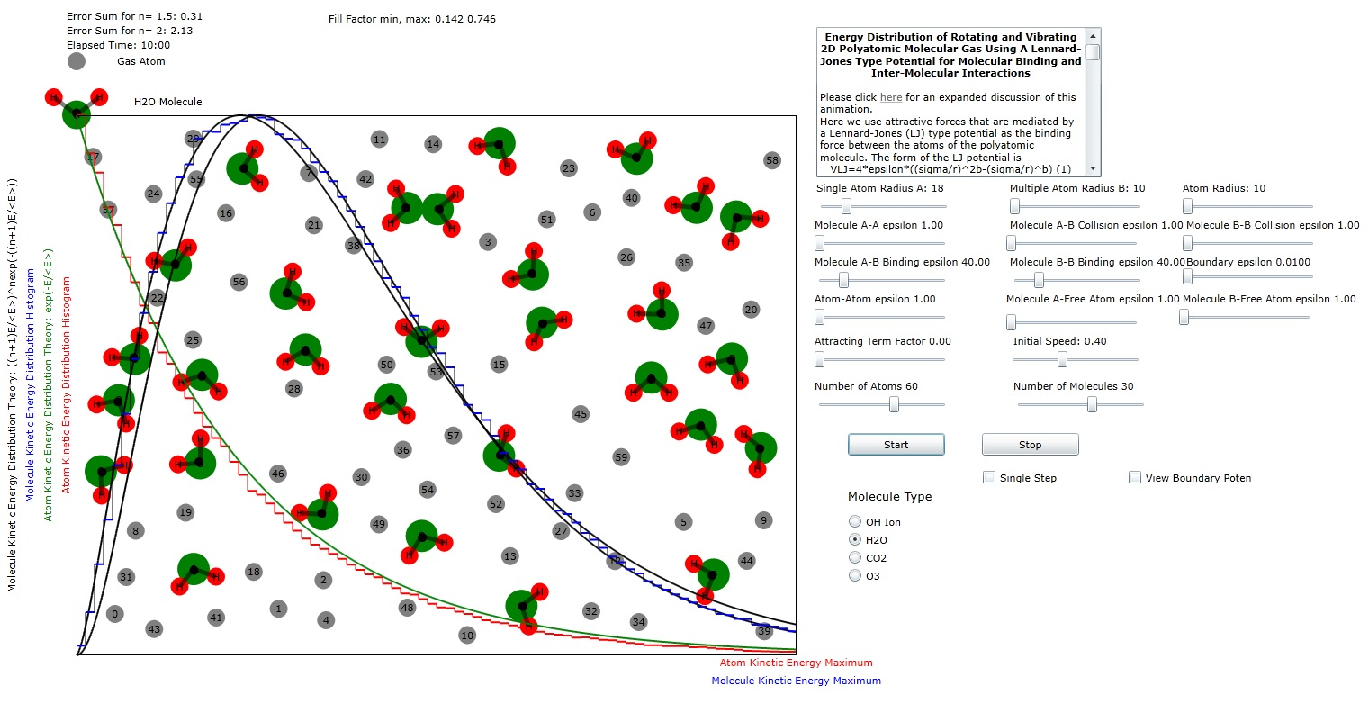
Figure 1: Plot of atomic and molecular distribution of molecule H₂O (water). The results (n=1.5) indicate that only two of the possible 3 modes of planar vibration are excited at these energy levels.
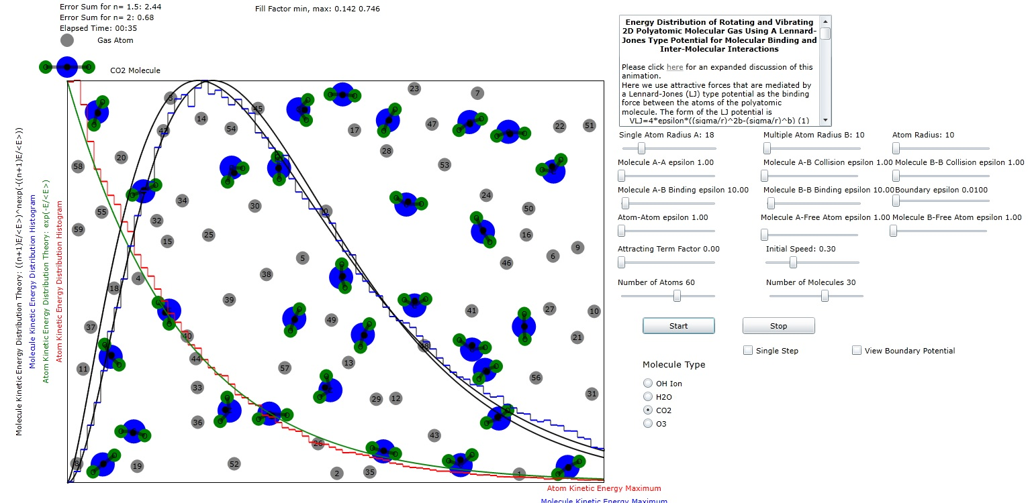
Figure 2: Plot of atomic and molecular distribution of molecule CO₂ (carbon dioxide). The results (n=2) indicate that all of the possible 3 modes of planar vibration are excited at these energy levels.

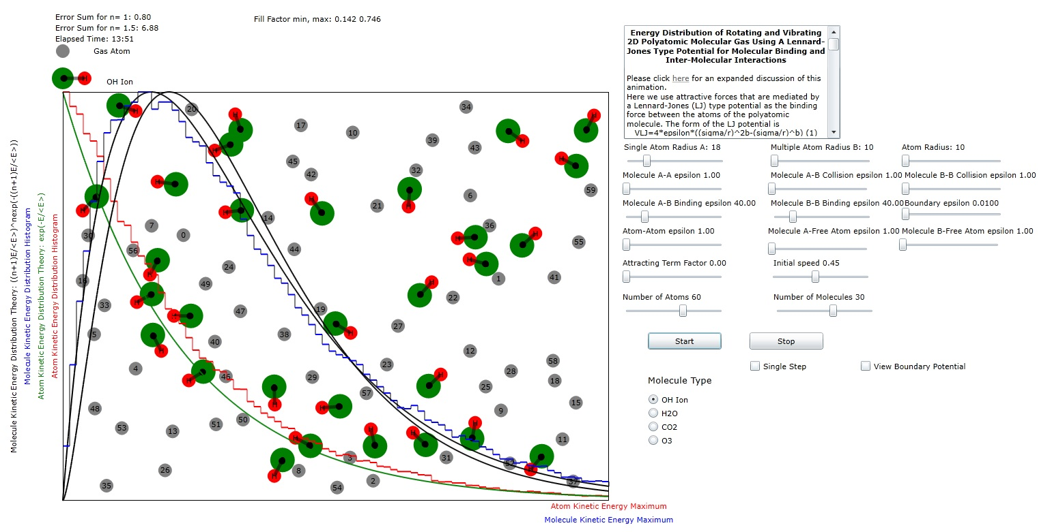
Figure 3: Plot of atomic and molecular distribution of the OH ion (hydroxide). The results (n=1) indicate that single mode of planar vibration is marginally excited at these energy levels.

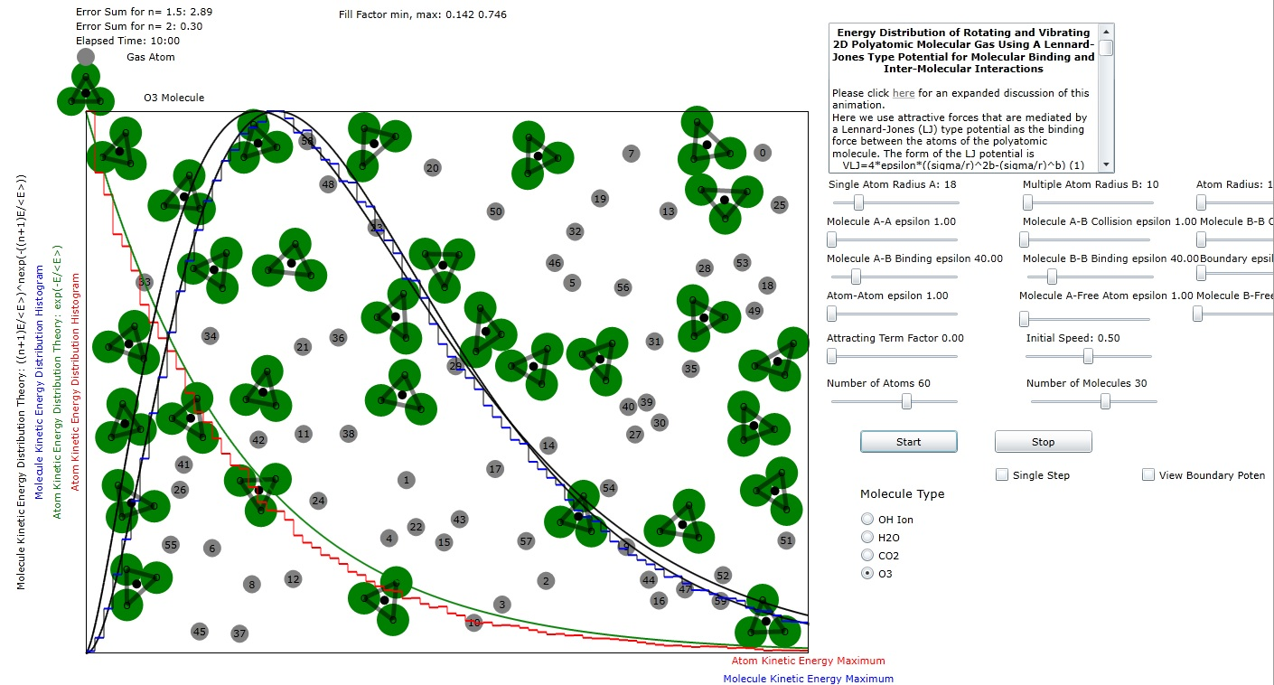
Figure 4: Plot of atomic and molecular distribution of molecule O₃ (ozone). The results (n=2) indicate that all 3 of the possible 3 modes of planar vibration are excited at these energy levels.

Analysis
For each degree of freedom, the multiplier of the fraction in the exponential increases by 1/2 while the power of the multiplier in the expression for energy distribution increases by 1/2. Then for 2n+2 degrees of freedom, the expression for distribution of energies is
where T is the total kinetic energy of the molecule.
If we want to convert this to a probability we must set the integral from 0 to infinity of f(E) to 1:

The integral in the denominator is fairly simple letting :
and therefore

