Graphics Description

Figures
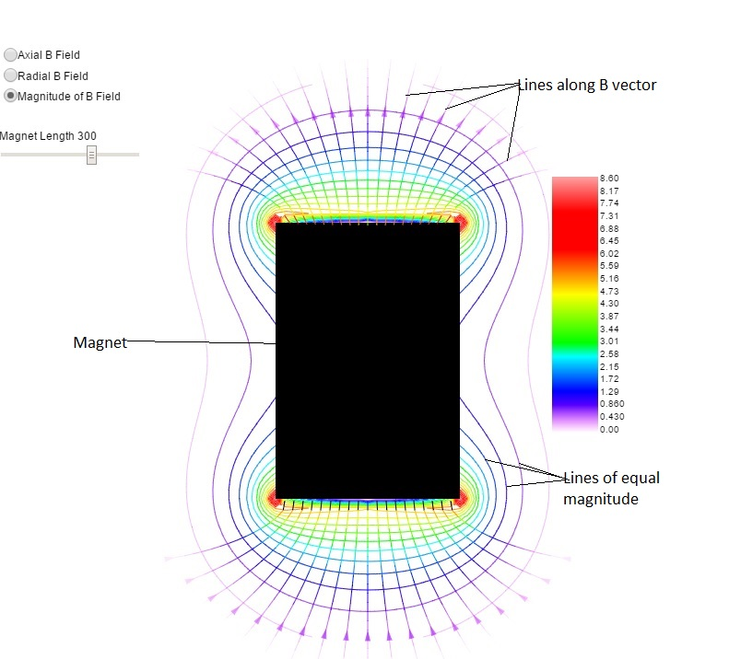
Figure 1: Contour plot and vector lines ("lines of force") of the permanent magnet shown as a black rectangle. The magnet is really a cylinder with its axis along the vertical direction. The contour plot shown is the magnitude of the z and r components of the magnetic field. The vector lines are plotted along the direction of the magnetic field and their segment colors correspond to the magnitudes of the field as indexed by the color bar at the right. In this same page, both radial and axial contour plots are available as a learner selection.

