Graphics Description

Figures
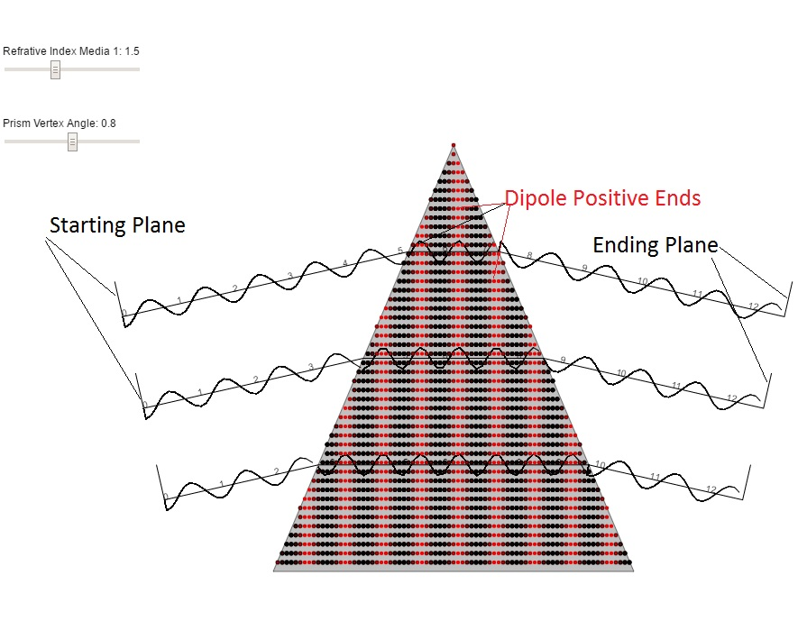
Figure 1: Wave picture of prism reflection. As shown the incident waves start at the starting plane and their wave maxima remain aligned with the maxima of the other two waves. When the waves enter the prism, this alignment still prevails even though the wavelength becomes considerably shorter. In addition, inside the prism, the wave maxima are aligned with the vertical red stripes which represent the positive ends of the dipoles that mediate the propagation in the prism. At both the entrance and exit of the prism, the phase of the wave is continuous. This continuity follows from the requirement that the force, due to the electric field of the wave, on the dipoles at the surface not be double valued.

