Pressure Calculation for High Density Gas

Introduction
Most simpler ideal gas pressure calculations do not take into account that the mean free path (mfp) of gas atoms is often much shorter than the dimensions of the container. In this document, I will include the effect of the small mfp through the use of what I will call fuzzy statistics.

Definition of Mean Free Path
First I should define what the mfp is. The mfp is the average distance between inter-particle collisions. It can be computed from the collision cross section that the particles present. For 3 dimension hard sphere particles of radius r the collision cross section, σ, is
and for 2 dimensional disc shaped particles, the collision cross section is
If the density of the particles is n then the mean free path is computed from the equation:
where the script L that is the mfp represents the distance that a particle can travel with an exponential probability of not hitting another particle. Solving equation for mfp we obtain:

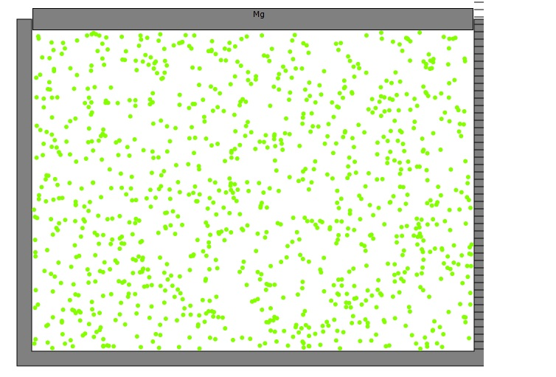
Figure 1: Picture of gas container with a line which is within 1 mean free path (mfp) from the right hand wall.

Calculation of Rate of Wall Hits
Since we may assume that the atoms are uniformly distributed along the x direction, we can clearly state that the number of atoms between the mfp line and the right boundary is
where N is the total number of atoms and W is the full width of the container. Again, we can assume that half of these atoms have velocity v_{x} toward the right hand boundary and the other half have the opposite v_{x} sign. Essentially all of the n_{mfp-x+}/2 atoms will be able to hit the right wall in a time
where <v_{x}²> is the average value of the square of v_{x}.
Now it is much less likely that atoms that are, for example, 2mfp from the right boundary will make collisions with the right boundary in the short time δt so we will ignore these.
In order to get an estimate of the pressure we need the rate that atoms hit the right wall and that dn/dt:
and thus the mean free path has cancelled out. This does not mean that this expression would be correct for any distance from the right hand boundary (see Critique).

Calculation of Pressure
Now each atom that hits the right wall and does not stick transfers momentum 2mv_{x} to the wall where m is its mass. So the total force on the right boundary is
The pressure, P, is defined as the force per unit area so it is the force divided by the area of the right boundary
where H is the height of the container and D is the depth of the container, its dimension into the screen.
Finally we can recognize the m<v_{x}²> term as a constant times the average translational energy of the gas atoms. In the case of three dimensions each of the three dimensions will contain 1/3 of the total translational energy, E_{t}, so the constant for m<v_{x}²> is 2/3E_{t}. Therefore we can give the pressure as
where we have written E_{t}=Nm<v²>.
We can also identify the product WHD as the volume of the container:
In a totally similar way we can write the pressure in 2 dimensions as:
where A is the area of the sheet that bounds the container.

Critique
Since the mfp cancels out when computing the rate of wall hits, some might say that we could use any distance as the range that the atoms traverse before hitting the right hand boundary. However, any distance greater than mfp will result in significantly larger times before wall collisions because of inter-particle collisions. That would contradict the statement that the particles within the boundary are not impeded by particle collisions. We could, however draw the boundary closer to the right wall than the mfp and that would not contradict the statement about no collisions. In fact that is one way to avoid the question of fuzzy statistics. However, if we used this very short distance concept in a computer animation we would have problems because of the very small number of atoms, δn, in this small volume.

Conclusion
I have shown using somewhat fuzzy statistics that the pressure for a dense gas will be about the same as that for a very rarified gas. In a rarified gas atoms can pass the full width of the container without colliding with other atoms and therefore the expression for δt is W/<v_{x}> while the expression for n is just N and thus the dn/dt becomes the same as we gave in equation and the result for pressure is the same as equation .

