Refraction in two Media Layers

Figures
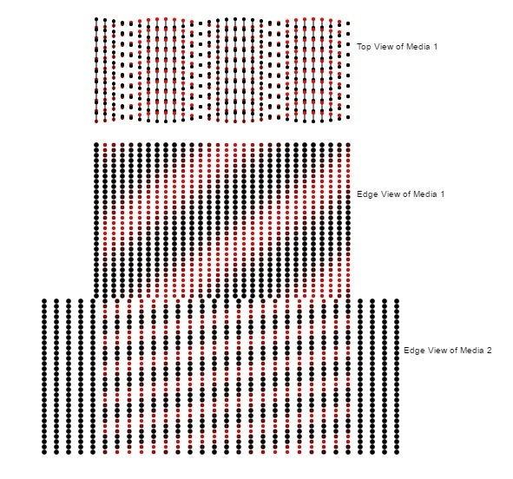
Figure 1: Top view and edge view of the dipoles in tow transparent media with an S polarized electromagnetic (em) wave incident on the top media. With s polarization, in edge view, you will see only the red (positive) or the black (negative) end of the dipole and these will oscillate at the frequency of the em wave. In the edge views, note the continuity of the wave phase at the interface between the two media. This is a more accurate way of showing how Snell's law is obeyed. The usual way is that the tangential component of the wave vector is the same on both sides of the interface. In the top view, the bottom edge of the top view is coincident with the near top corner of the edge view. So the colors at the bottom edge of the top view should agree with the color of the top edge of the edge view as is the case.

