Potential-Bound and Rigidly Bound Rotor Energy Distribution in 2 Dimensions

Introduction
We have previously shown animations of rigid rotors where the separation between the end atoms is constant. Here we will discuss the energy distributions attained by rotors that are bound by a strong potential energy variation. This will be a more realistic model of diatomic molecule motion and energy distributions. For this model, all of the forces between particles will be mediated by central forces similar to the those of the Lennard-Jones potential. Central force here means that the force is along the line separating the interacting particles and the value of the force is a function of the separation. For microscopic particles there are very few exceptions to this type of force.
An important revelation that we come to as a result of this simulation is that some of the terms used in discussing energy distributions of complex particles are misleading. In particular the term "degrees of freedom" as applied to the energy distributions and heat capacity needs to be changed to "modes of energy interchange". See the section below for a discussion of this.
Another revelation is that two revered tenets of physics, linear and angular momentum conservation, are never used in this simulation (in fact it appears that these conservation principles are really only a mathematical convenience, mostly useful for hard body interactions). Momentum conservation needs to be renamed to "directed energy conservation". See the section below for a discussion of this.
Last but not least, I have included a section on how I set up the initial parameters of the rotors according to their rotational speed.

Energy Distribution Functional Results
Simple 2 dimensional constrained atoms have the energy distribution:
where f(E) is normalized to a peak value of 1.0.
For rotors bound by a Lennard-Jones type potential and constrained to 2 linear dimensions we obtain the following distribution also normalized to 1 at its peak:
Figure 1 shows the resulting plots for the potential-bound of rotor as well as the plot for atoms in equilibrium with the rotors.
For rigidly bound rotors and constrained to 2 linear dimensions we obtain the following distribution also normalized to 1 at its peak:
Figure 2 shows the resulting plots for the rigid rotor as well as the plot for atoms in equilibrium with the rotors.

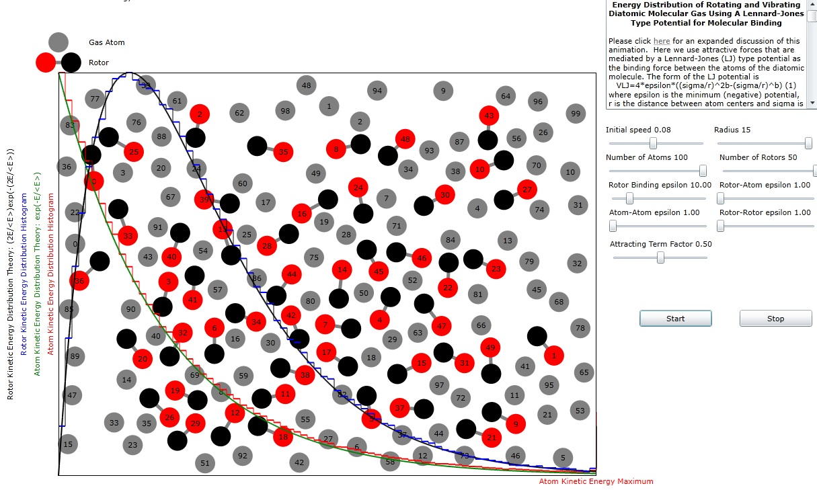
Figure 1.Distribution of Energies of both Atoms and Potential Bound Rotors.
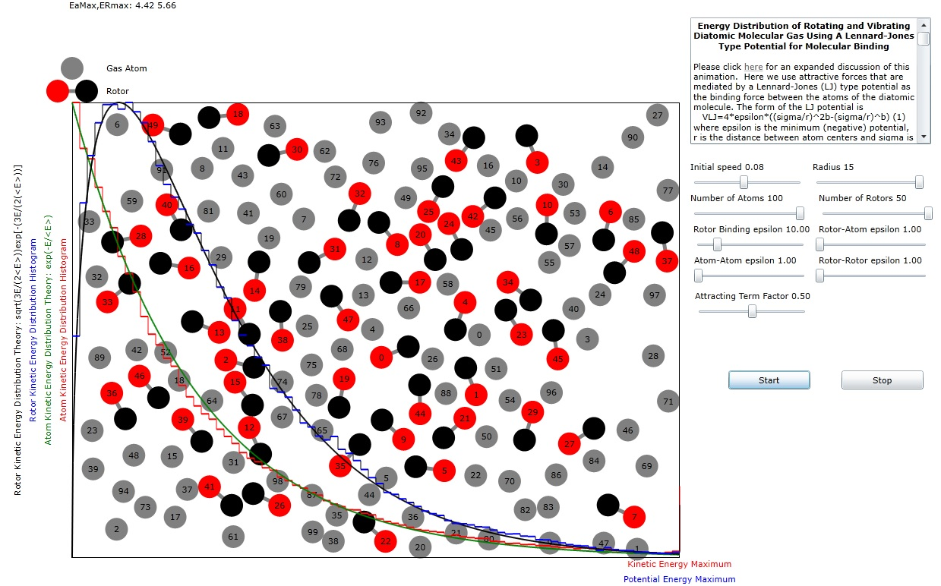
Figure 2. Distribution of Energies of both Atoms and Rigidly Bound Rotors.

Renaming the Term "Degrees of Freedom" in Reference to Statistical Energy Distributions
An important revelation that we come to as a result of this simulation is that some of the terms used in discussing energy distributions of complex particles are misleading. In particular the term "degrees of freedom" as applied to the energy distributions and heat capacity needs to be changed to "modes of energy interchange". The reason for this change is that we have here achieved what would normally be called an increase of the degrees of freedom, not by increasing freedom of movement, but by applying a variable constraint. For example, a gas of particles that can move in two dimensions has two modes of energy interchange, (x1,y1) may become (x2,y2) and vice-versa. A gas of particles that can move in only one direction has only one mode of energy interchange, x1 may become x2. For our non-rigid rotors, energy interchange can occur 4 ways. Two of these modes are the simple linear interchange of the center of mass motions mentioned above. Another is the conversion of center of mass energy to rotational energy and vice-versa. Yet another is the conversion of center of mass energy to rotational energy and vice-versa. Since vibrational motion is orthogonal to rotational motion for a diatomic atom, there is no direct way for energy conversion between these two motions to happen.

Renaming Linear and Angular Momentum Conservation
An important revelation of this simulation is that two venerable tenets of physics, linear and angular momentum conservation, are never used in this simulation. In fact, it appears that these conservation principles are really only a mathematical convenience, mostly useful for hard body interactions. The only way that either of these properties change is via an interaction with a spatially and time varying potential energy. This potential energy can either yield kinetic energy or accept kinetic energy of the particles by changing their velocity.
It would at first appear that the particle's change of velocity could be in any direction and that would still satisfy the requirement of energy conservation. However, one must take into account that an arbitrary direction of the velocity change has a very important impact, through time integration of this velocity change, on the new positions of the particle. If that position turns out to be not in agreement with the force provided by the potential, then energy on subsequent integrations of the velocity will not be conserved. So, for interactions between particles which result in velocity change, I prefer to change the term "momentum conservation" to a more accurate term "directed energy conservation" which preserves the innate vector nature of energy conservation as well as the scalar nature of energy conservation.

Directed Energy Conservation
A perfectly good equation for iteration of velocities and positions is:
where the upside down triangle stands for spatial gradient, T is the kinetic energy and V is the potential energy. Forces that can affect the particle's velocity are proportional to the gradient of the potential energy along the direction to the particle.
where the carat on top of r stands for unit vector along that direction.

T has the following form
where v_{r} is the velocity along the direction r.
Then the gradient of T along the direction of the force is
We can use the chain rule to convert this expression to derivatives with respect to time:
The particle's velocity component in the r direction is updated incrementally using equation . The position of the particle is then updated using this new velocity.

Rotor Bound by Lennard-Jones type potential
Rather than making the spacing between the disks rigid, we can use a potential to keep the rotor disks together. For this we will use a modified Lennard Jones potential..
The normal LJ potential is given by
where the minimum potential is -ε and σ is usually chosen as a nominal separation between disks.
We will change this expression by assigning variables to the power of he σ/r ratios.
The value of r at the minimum potential is computed by setting the derivative of V(r) equal to zero and is
This is also the separation r where the force between particles goes to zero. We can use totally similar math to compute the spacing where maximum attractive force occurs. First defining a power ratio, Pr, using the second derivative of the potential we have:
we find that the spacing where maximum attractive force occurs is:
and this leads to the value of the maximum attractive force:
Using F_{max} we can compute the maximum rotational speed that the diatomic molecule can have, and remain bound, for a given value of ε:
or
where m is the mass of a single atom.
We can choose an initial separation for the atoms such that their separation stays constant by solving for r₀ in the following equation:
Equation can always be solved by a Newton-Raphson numerical method or it can be solved algebraically for the special case a=2b:
For that special case, if we let then we can rewrite equation

and equation is recognized as a simple quadratic equation. The solution for u is
Again, for the special case a=2b we can write a better expression for v_{max}
When the rotor is hit by another particle, it could easily be unbound unless the value of ε for the rotor binding is much larger than the value for the other particle. It seems prudent to choose the interaction potential for this kind of collision to be:
where ε_{A} is the value of ε for the atom and ε_{R} is the value for the rotor's binding. This should tend to maintain the binding of the rotor components.

