Modes of the Schrodinger Equation for the 1D Mexican Hat Potential

# Introduction

This documents the quantum mechanical results for the Mexican Hat Potential. The parent page shows the positions, velocities, and the position occupation times of the potential.

# Math

The Schrodinger equation



can be solved with reasonable accuracy using a finite difference matrix of the form shown below.



*Figure 1: Schrodinger Equation in Finite Difference form with just three elements.*

The potential used for the plots below is shown in Figure 2.



*Figure 2: Mexican Hat Potential used for the modes computed below.*

The constant values used were for simplicity  and  .

# Results

Figure 3 shows the lowest three modes while Figure 4 shows the next lowest three modes. The fact that the wave function amplitude is very small near the center peak of the potential is probably due to tunneling of the particle through the peak.

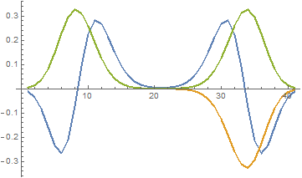 

*Figure 3: Lowest three modes of Mexican Hat Potential along with their energy eigenvalues listed in the legend.*

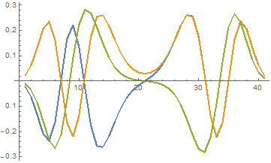, 

*Figure 4: Next lowest three modes of Mexican Hat Potential along with their energy eigenvalues listed in the legend.*