This is a test of MathType.
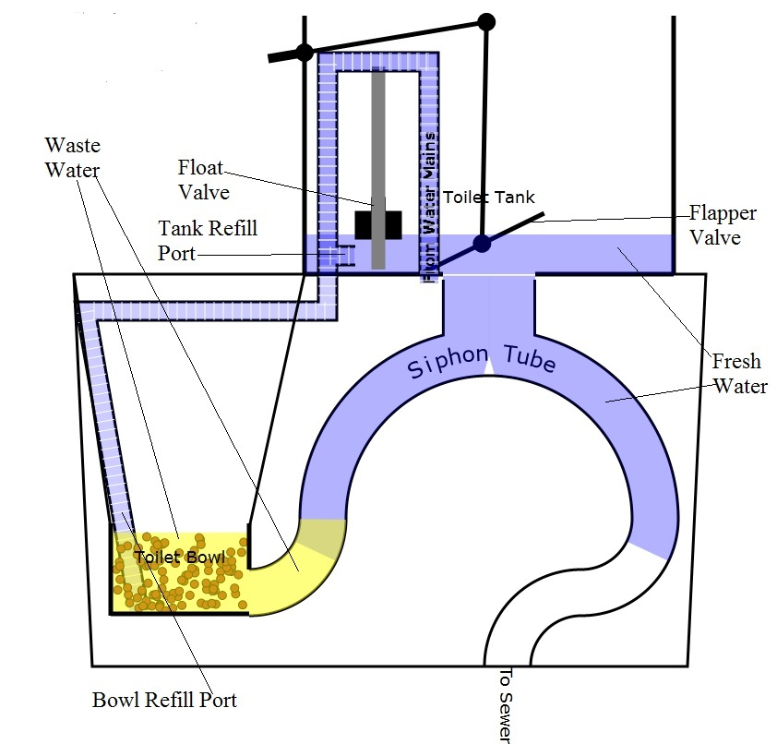
Figure 1

End of test

